|  |  |
| --- | --- |
| **Course: Computer Logic and Design Lab** | **lab instructor : Muhammad Salman**  **Course Instructor:** |

**Section E-2**

**LAB 3**

**Total Marks:20**

**Purpose of this Lab:**

* Truth table of logic circuit and its implementation
* Boolean identities
* Simplification of Boolean identities
* Implementation on Logic trainer
* SOP and POS
* Understanding of the logicWorks
* Max terms and min terms

**In Lab Statement:**

**Operation of AND gate according to itstruth table**

Install IC (integrated circuit) for AND (74LS08) on the breadboard according to the connection diagram given below.

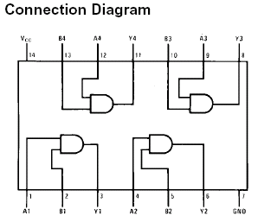

**Operation of OR gate according to its truth table**

Install IC (integrated circuit) for OR (74LS32) on the breadboard according to the connection diagram given below.

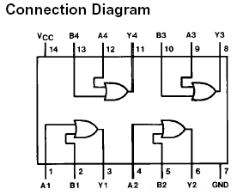

**Operation of NOT gate according to its truth table**

Install IC (integrated circuit) for NOT (74LS04) on the breadboard according to the connection diagram given below.

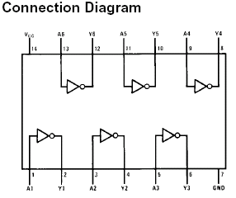

**Truth tables, Circuits and Boolean Equations**

**Truth tables:**

Q4- Draw the truth tables of Boolean Equations and implement it on logic trainer

1. A**.**B' + A' b. A.B + A'**.**B' c. (A**.**B**.**C)+(A+B+C)

**Circuit Diagram:**

Q5- Draw the circuit diagram of the following Boolean Equations.

a. A**.**B' + A' b. A.B + A'**.**B' c. (A**.**B**.**C)+(A+B+C)

1. (A**.**B**.**C)**.**(A+B+C) e. BC'D'+A'B'CD'+ABD'

**Boolean Identities:**

Q6- Prove the following with the help of Boolean identities and implement it on breadboard.

1. **X+XY = X**  b. **X(X'+Y) = XY**  c. **X+X'Y = X+Y**

**Simplification of Boolean Identities**

Q7-Simplify the following Boolean equations

a. (**AB)**'**(A**'**+B)(B**'**+B)** b. **C+BC** c. **(A+C)(AD+AD')+AC+C**

**POS**

Q8- Convert the following to POS form by using the distributive law

**xy' + yz'**

Q9- Convert the following to POS form by using the De Morgan laws

**b′d+ac′d′**

**SOP**

Q10-Write the following in SOP form

1. **(x'+y)(y'+z)b.**(x + y’)(y’+ z)

**Max terms and min terms:**

Q11.Find Max terms from the following Min terms

1. F(X,Y,Z) =Σm(1,3,6,7)
2. F(X,Y,Z) =Σm(0,1,2,4,6)
3. F(A,B,C) =Σm(0,3,4,5,7)

**Implementation on logic Trainer:**

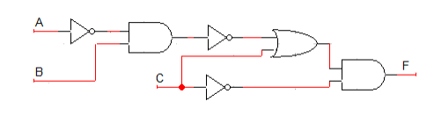

**LogicWorks:**

Q13.For the Boolean functionsimplement the circuit on Logic Work 4 and make a truth table.

**F1 = XYZ + X’Y + XYZ’**

**POST LAB:**

Q1- Draw the truth tables of Boolean Equations and implement it on logic trainer

a.(A**.**B**.**C)**.**(A+B+C) b. BC'D'+A'B'CD'+ABD'

Q2- Draw the circuit diagram of the following Boolean Equations.

a. (A**.**B**.**C)+(A+B+C) b.(A**.**B**.**C)**.**(A+B+C) c BC'D'+A'B'CD'+ABD'

Q3.For the Boolean functionsimplement the circuit on Logic Work 4 and make a truth table

**F2 = [(A+BC’)(A’C’)]’+ C**

**Submission:**You have to submit the circuit diagrams and truth table in hardcopy. Use only A4 size sheets.Deadline is till next lab. Late submissions will not be graded.